

**DEPARTMENT OF SOCIAL SCIENCE, SENIOR BOYS**

**RISE OF NATIONALISM IN EUROPE WORK SHEET**

**NAME: EXAM.NO.: CLASS/SEC: 10/**

1. Associate the picture with the clue –
2. Select the picture by clicking on it
3. Move the picture in the right box, **DON’T FORGET TO CLICK SAVE**.

|  |  |
| --- | --- |
| **CLUE** | **PICTURE** |
| Simplified the administrative systems, gave a civil code and made the system of weights and measures uniform. |  |
| Decided the fate of Europe after 1815 and considered as the most intelligent brain in field of diplomacy |  |
| Succeeded in unifying Germany and used the famous blood and iron policy. |  |
| Called as the most dangerous enemy of social order and was termed as the most influential revolutionaries of Italy |  |
| The first to use the term Das Volk and Volkgeist, he supported Romantic Nationalism and wanted the Germans to be unified into one single nation. |  |

|  |
| --- |
| Teachers Observation: |

1. Observe the picture, then record your observations in the boxes given below

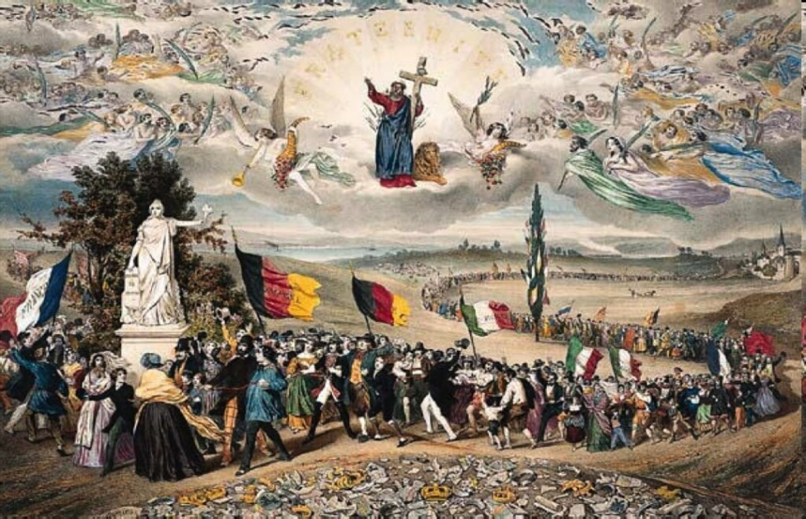

Who painted this image?

|  |
| --- |
| Federich Rouseau |

What is the debris in the foreground signifying?

|  |
| --- |
|  |

Name the statue observed in this picture.

|  |
| --- |
|  |

What is end result of this painting?

|  |
| --- |
|  |

|  |
| --- |
| Teachers Observation: |

1. The ideas of (the fatherland) and (the citizen) emphasized the notion of a united community enjoying equal rights under a constitution

(Fill the blanks and save)

1. State the major notions of united community as propagated by the revolutionaries in France.

|  |
| --- |
|  |

|  |
| --- |
|  |
|  |

|  |
| --- |
|  |

|  |
| --- |
|  |

|  |
| --- |
| Teachers Observation: |

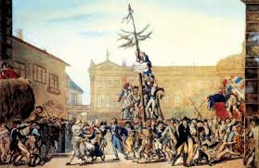

Observe the print above, and then record your observations as instructed.

Who painted this image?

|  |
| --- |
|  |

Which town is shown in this image?

|  |
| --- |
|  |

Why did the artist paint this image?

|  |
| --- |
|  |

|  |
| --- |
| Teachers Observation: |

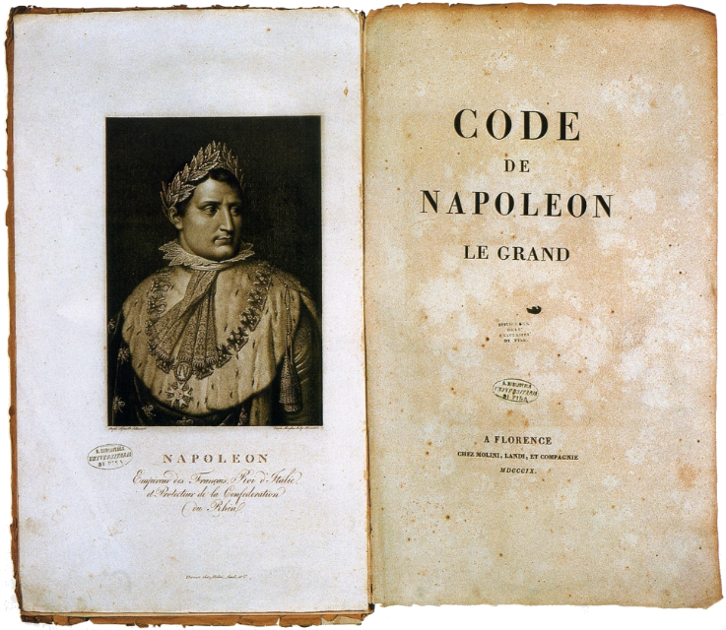

The Napoleonic Code is considered as the major achievement of Napoleon. Record below the major features of this code

|  |
| --- |
|  |

|  |
| --- |
|  |

|  |
| --- |
|  |

|  |
| --- |
|  |

|  |
| --- |
|  |

|  |
| --- |
| Teachers Observation: |

1. How was the Aristocracy different from the commoners in Europe?

|  |  |
| --- | --- |
| **Aristocracy** | **Commoners** |
|  |  |
|  |  |
|  |  |
|  |  |
|  |  |

|  |
| --- |
| Teachers Observation: |

1. State in the boxes below the significance of the ***zollverein***

|  |
| --- |
|  |

|  |
| --- |
|  |

|  |
| --- |
|  |

|  |
| --- |
| Frederic List Observations about ***zollverein*** |

|  |
| --- |
| Teachers Observation: |

1. 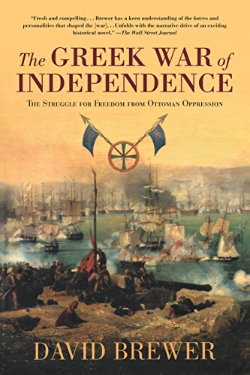

**Observe and record**

When did Greece won independence?

|  |
| --- |
|  |

Which treaty got Greece its independence?

|  |
| --- |
|  |

What was Greece referred as in context to Europe?

|  |
| --- |
|  |

|  |
| --- |
| Teachers Observation: |



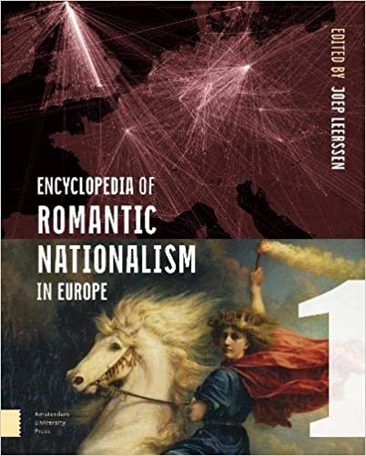

What is form of movement is usually Romantic Nationalism referred as?

|  |
| --- |
|  |

Which features the Romantic Nationalism focus on?

|  |
| --- |
|  |

Name two great Romantic Nationalists and the country they belonged

|  |
| --- |
|  |

|  |
| --- |
| Teachers Observation: |

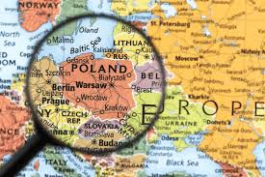

How did Language play role in Polish nationalism?

|  |
| --- |
|  |

How was folk dance instrumental in Polish nationalism?

|  |
| --- |
|  |

|  |
| --- |
| Teachers Observations: |

1. Trace the establishment of the Frankfurt Parliament.

|  |
| --- |
|  |

|  |
| --- |
|  |

|  |
| --- |
|  |

|  |
| --- |
|  |

|  |
| --- |
|  |

|  |
| --- |
| Teachers Observation: |

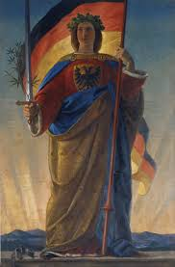

Name this Allegory.

|  |
| --- |
|  |

Which country this Allegory represents?

|  |
| --- |
|  |

What is the significance of the crown of leaves?

|  |
| --- |
|  |

|  |
| --- |
| Teachers Observation: |

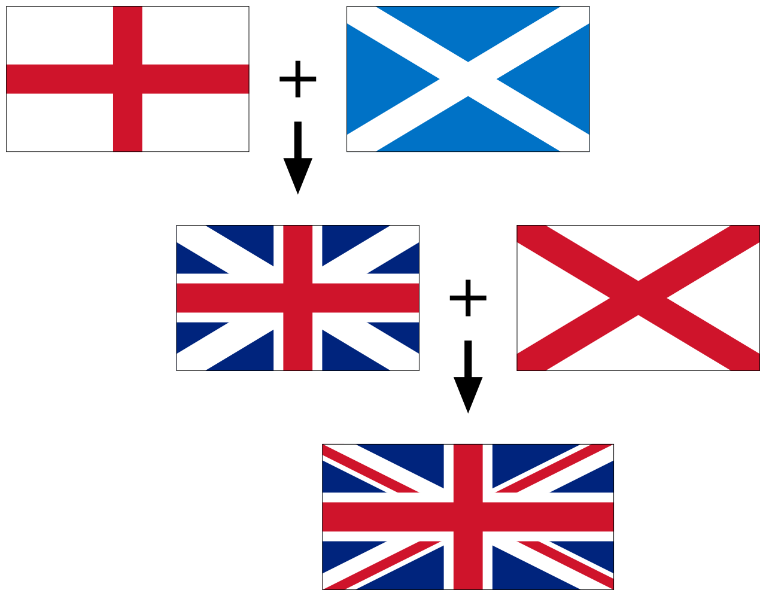

The Union Jack traces its growth from different flags –

Name the country whose flag is the red cross on the white background

|  |
| --- |
|  |

Name the country whose flag is the white cross on the blue background

|  |
| --- |
|  |

Name the country whose flag is a red cross in ‘X’ form on white background

|  |
| --- |
|  |

|  |
| --- |
| Teachers Observations: |

**PLEASE REMEMBER TO ALIGN THE TEXT AS THE BOXES MAY GET EXTENDED AND DISTURB THE ALIGNMENT. KINDLY REMEMBER THIS BEFORE SUBMISSION**.